Truncated Archimedean Solid

Definition
# Source: AI Source: Provided by: [Data Path: Persons Table -> ID Column: 1, Name_En Column: Motasem Essam] -> From: [ChatGPT] on [7/25/2026]
A Truncated Archimedean Solid is a polyhedron produced by cutting off vertices of an original Archimedean solid using planes.
The truncation process creates new polygonal faces while modifying the original faces, edges, and vertices.
These solids are related to Archimedean solids because their construction involves truncation operations applied to Archimedean polyhedra.

Examples of Truncated Archimedean Solids
# Source: AI Source: Provided by: [Data Path: Persons Table -> ID Column: 1, Name_En Column: Motasem Essam] -> From: [ChatGPT] on [7/25/2026]
The following examples are included in your source document:

Truncated Cuboctahedron
# Source: AI Source: Provided by: [Data Path: Persons Table -> ID Column: 1, Name_En Column: Motasem Essam] -> From: [ChatGPT] on [7/25/2026]
Produced by truncating the vertices of a cuboctahedron.
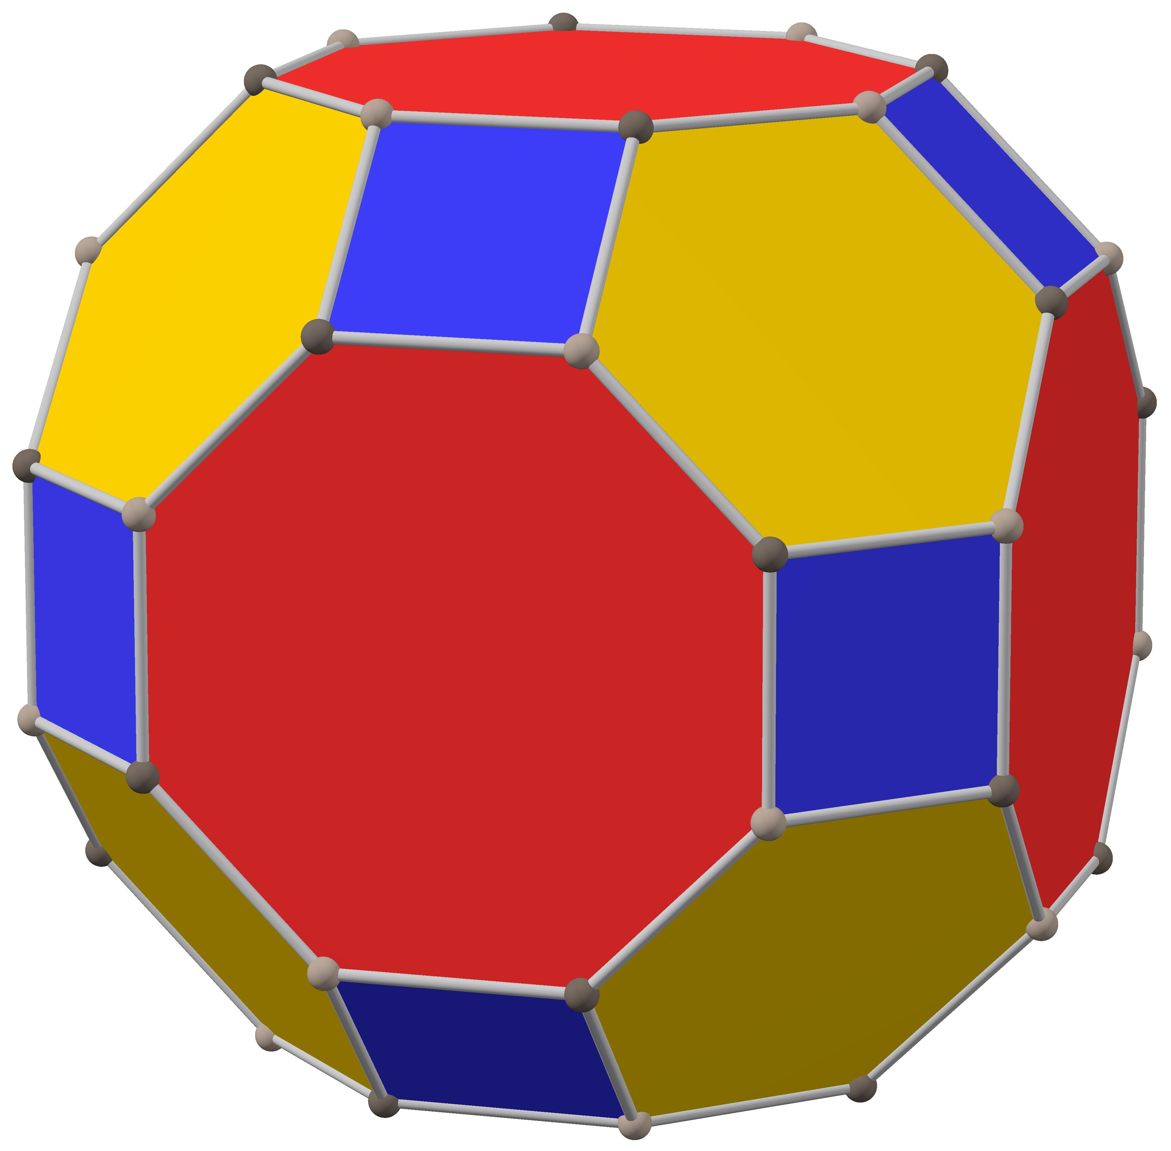

Truncated Icosidodecahedron
# Source: AI Source: Provided by: [Data Path: Persons Table -> ID Column: 1, Name_En Column: Motasem Essam] -> From: [ChatGPT] on [7/25/2026]
Produced by truncating the vertices of an icosidodecahedron.
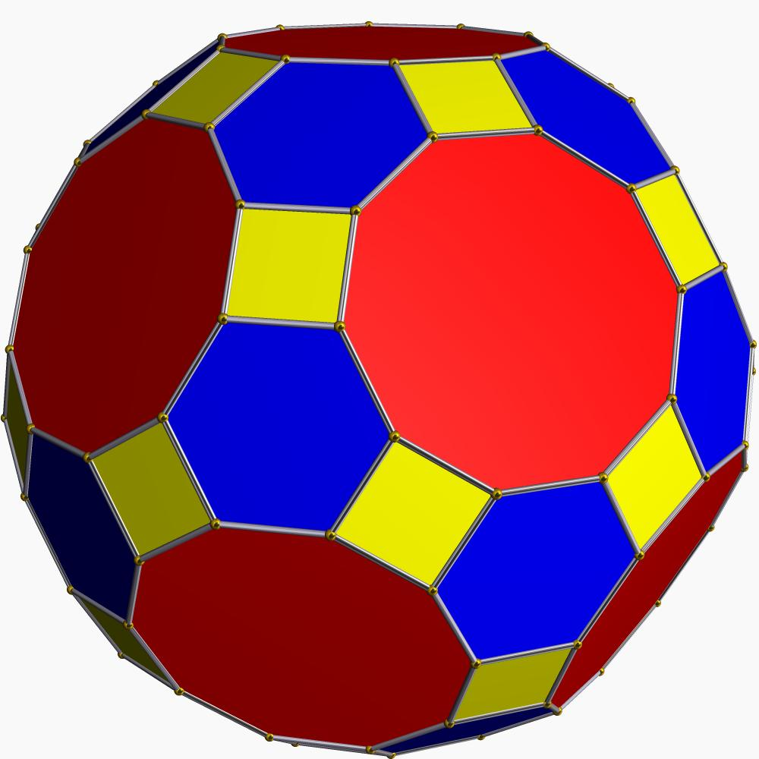

Truncated Rhombicuboctahedron
# Source: AI Source: Provided by: [Data Path: Persons Table -> ID Column: 1, Name_En Column: Motasem Essam] -> From: [ChatGPT] on [7/25/2026]
A related solid included in the source document as a distinct Archimedean solid produced through a particular truncation construction.
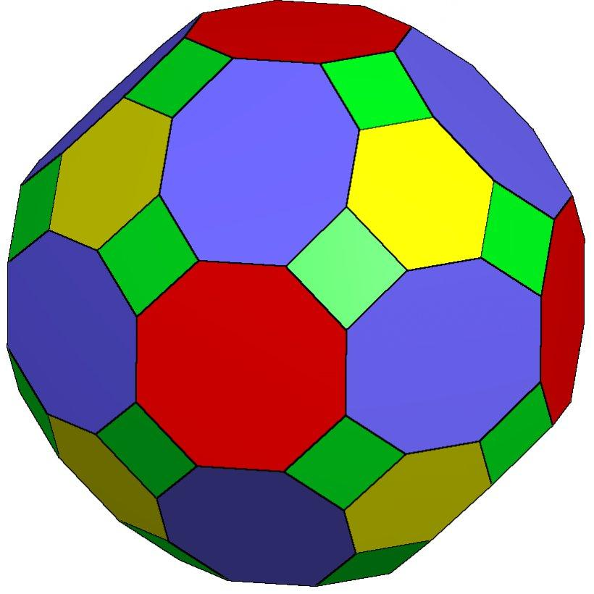

Geometric Characteristics
# Source: AI Source: Provided by: [Data Path: Persons Table -> ID Column: 1, Name_En Column: Motasem Essam] -> From: [ChatGPT] on [7/25/2026]
Truncated Archimedean solids generally have the following characteristics:
- Original Faces: Polygonal faces inherited from the original solid.
- Truncation Faces: New polygonal faces created by cutting off vertices.
- Modified Edges: Original edges are shortened or modified.
- New Edges: Edges created by the intersections of cutting planes with the original faces.
- Symmetry: Depends on the original solid and the uniformity of the truncation operation.

Key Points
# Source: AI Source: Provided by: [Data Path: Persons Table -> ID Column: 1, Name_En Column: Motasem Essam] -> From: [ChatGPT] on [7/25/2026]
- They are associated with Archimedean polyhedra.
- They are formed through truncation operations.
- Truncation creates new polygonal faces.
- Their face arrangements depend on the original polyhedron and the truncation method.
- Uniform truncation can preserve the symmetry of the original solid.

Conclusion
# Source: AI Source: Provided by: [Data Path: Persons Table -> ID Column: 1, Name_En Column: Motasem Essam] -> From: [ChatGPT] on [7/25/2026]
Truncated Archimedean Solids are polyhedra associated with truncation operations applied to Archimedean solids. Their defining geometric feature is the creation of new polygonal faces through cutting operations, producing modified three-dimensional structures.

